Ideation Phase

Define the Problem Statements

|  |  |
| --- | --- |
| **Date** | 18 October 2022 |
| **Team ID** | PNT2022TMID31193 |
| **Project Name** | Retail Store Stock Inventory Analytics |
| **Maximum Marks** | 2 Marks |

Problem St

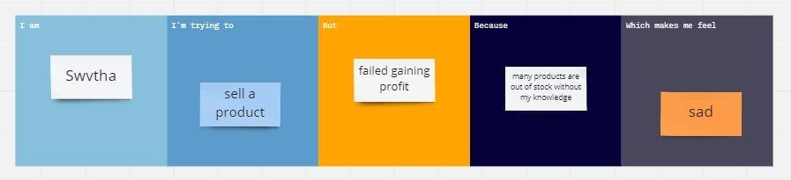Problem Statement 1:

Asliya

Problem Statement 2:

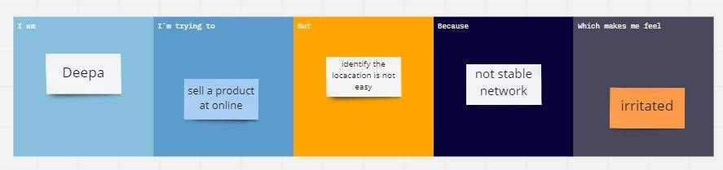

Keerthana

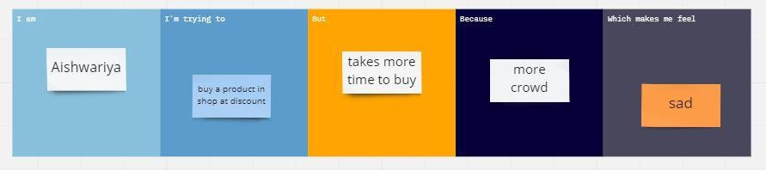Problem Statement 3:

Geetha

Problem Statement 4 ;

Anitha